2 Minute Form
Trip Name: Lake Ohakuri NE – On your bike - Waikato River
Check-in Name and Phone: Ian Henderson at 078832703
Date: Branch: North Shore
Leaders
Cell Phone Number
VHF Call Sign &/or Vessel Name
Vehicle make, model, registration, colour
General Plan
Note: If plan changes, you must notify your Check-in person.
Latest Time Off the Water |  |  |  |  | TMP used²⁰
Tide/ Forecast Lake Level | Low n/a |  |  | High
Communications Carried²¹
Communications | We will be communicating as a group on VHF Channel 06_____
Equipment Carried
Trip Report
(Use other side if more space required)

Activity | Lake Ohakuri NE – “On your Bike” | Centre | North Shore | Location – Waikato River |  |  |  |  | Difficulty¹ |  | Strong beginners
Activity Description | Drive to Lake Ohakuri Dam. Paddle up the NE arm towards Mangatete Stream. Stop at the mai mai with the bicycle water pump (6km up) and the bridge on Poutakataka Rd.(10km up) Explore the various inlets on the way back.(22km) |  |  |  | Leader qualification req.² |  | Sea Kayak Leader
Get in Location | Ohakuri dam |  |  |  | Map no.⁴ |  |  |  | Distance |  | 22km
Get out Location | Ohakuri dam |  |  |  | Coastguard Channel |  | 16 |  | Nowcasting |  | 22, 23
Emergency get out ⁵ | Along river bank |  |  |  | Emergency / Coastguard Station |  |  |  | Phone
 |  |  |  |  | Drinking Water⁶ | River |  | Toilets⁷ |  | no
Emergency Response | Refer Emergency Response Booklet |  |  |  |  |  |  | Parking⁸ |  | At dam
Specific Equipment Required⁹ |  |  |  |  | Working Communications equipment in this area¹⁰ | VHF. Cellphone coverage in gorges is unreliable – may need to climb a hill, and then need to ring a landline |  |  |  |  |  | PLB  VHF  Sat Phone
Other resources  and notes¹¹ | Access/parking –1 hr drive via Kinleith, from Arapuni. Turn right on to Ohakuri Rd, then turn right just before Ohakuri dam |  |  |  | Weather Parameters¹² | 15knot or less head wind
Previous incidents¹³

Safety Management¹⁴
Hazard |  | Significant?  - E/I/M |  | Management Strategy¹⁵ |  |  |  | Hazard | Significant?  - E/I/M | Management Strategy¹⁵
Cold Water |  | Yes - M |  | Carry spare dry clothes and shelter |  |  |  | Deep Water | Yes - E | Correctly fit PFDs
Medical Conditions |  | Yes - M |  | - Leader has first aid qualification  - Ask customers about medical conditions |  |  |  | Bad Weather | Yes - M | Understand weather forecasts.  Have back up plans or pull out if necessary
Capsizing |  | Yes - M |  | - Correctly fit PFDs  - Skills at performing rescues. |  |  |  | Heat / Sun | no - M | - Protective Clothing (worn), Sunglasses, Hat  - Sun Screen  - Plenty of drinks
Panic |  | Yes - M |  | Ensure conditions match level  of skills |  |  |  | Obstacles | Yes - M | Blackberry bushes, if need emergency exit. Excellent picking in Feb!
Duck shooters |  | Yes - M |  | Avoid the first w/e of May as it is the opening of duck shooting season. |  |  |  | Other Vessels | Yes - M | - Understand the “rules of the sea”  - “Be seen” – Have two of the following; flag, brightly coloured kayak, brightly coloured Pfd or hat. At night: an all- round white light & a powerful torch.
Cold camping |  |  |  | Cold camping conditions in winter –beanie, thermals, woollies, hot water bottle advised. |  |  |  | Power boats, water skiers, wake-boarders. |  | Keep to the sides of the lake where possible.  Keep a good lookout.
Written up by: | Ruth E. Henderson |  | Approved By: |  | James Fitness | Signed: |  |  | Date: | 2/9/2014 | Review in: | 12 months from date of approval

Additional Information Sheet (Optional)
Introduction (A general introduction)
Description (A description of the tour – as if you were selling the idea to someone)
Local Attractions |  | Transport/ Local Operators
 | Contact details |  | Contact details
Local Eateries
 | Contact details
Accommodation/ Campsite Locations |  |  | Facilities
Name | Camping at private property (Private home with camping in adjoining field. Use of house facilities inc hot showers).  Or freedom camping at Jones Landing (shade trees, flush toilets only) |  |  |  | Fuel | no
Phone |  |  | Showers | no | Power | no
E-mail |  |  | Toilets | yes | Water Access | yes
Website |  |  | Laundry | no | Pool | no
Physical Address |  |  | Water | river | Fires Allowed | Yes in winter
Other |  |  | Supplies | no
Other information

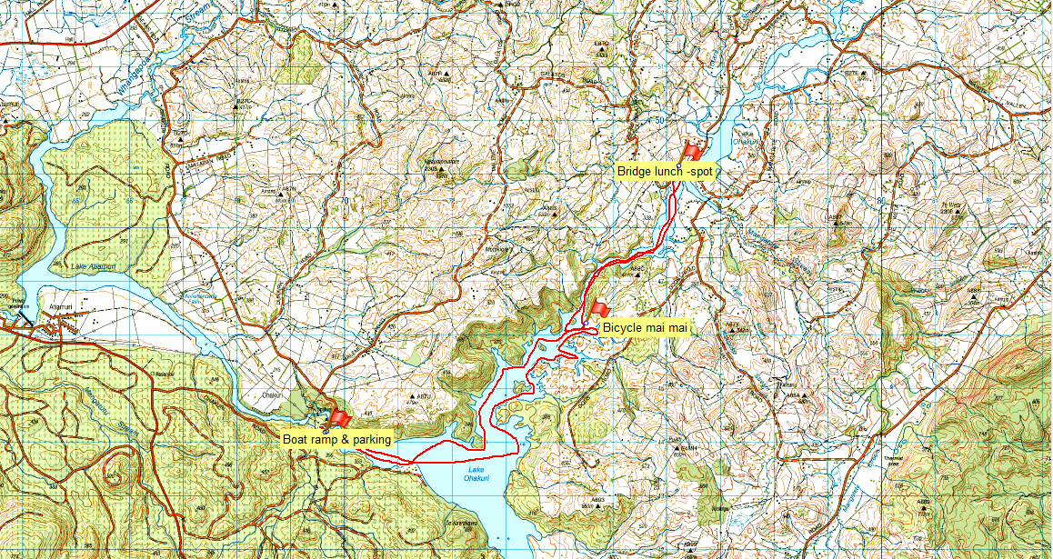

Activity Equipment Check list
Equipment List
- Helmet (rivers & surf) Group Gear
❑ Beanie / hat  Split paddles
❑ Thermals  Repair kit
❑ Paddle Jacket  Fire lighting
❑ PFD  Cooker/thermos
❑ Spray deck  Spare thermals
❑ Booties  Tow system
❑ Water & food  1st Aid Kit
❑ Kayak & paddle  Flares
Group - Oceans & Lakes  Compass
❑ Pumps & Paddle Floats  Charts / Maps
Group - River  GPS (optional)
❑ Throw ropes  Knife (cut rope)
❑ Pin kit & saw  Emergency Shelter

In case of emergency: Dial 111, Mayday :VHF Channel 16

Kayaking Check list

❑ Trip plan
❑ Latest weather forecast
❑ Conditions match skills?
❑ Hyperthermia (hot) &
Hypothermia (cold)
❑ On & off water safety
❑ Environmental concerns
❑ Emergency Procedures include emergency get out.
❑ Working communication devices
e.g. VHF radio, mobile phones, PLB
❑ Specific safety issues for this trip
❑ Participant list
❑ Any medical conditions
❑ All participants keen to proceed?

❑ Trip Plan/ 2-minute form lodged with Ops. Manager

Appropriate wind conditions to run trips:
Novice - no significant surf or swell, wind under 15knots
Intermediate- surf or ocean swells less than 1.5 meter or wind under 25 knots.
Advanced- any condition that is suitable to the trips aims

At conclusion of trip:
Contact check in person
Group Debrief.

Check in Person Ph:
__________________ Mobile
__________________ Work
__________________ Home

Activity Document Cover Sheet

Activity:
Date of Activity:

Activity reports. Is all relevant information present:
– Approved Trip Management Plan (TMP)/ 2 minute form
– Club Trip Participant Sheet
– Weather forecast
– Activity Check List
– Trip report (May be on the 2 minute form)
– Accident / incident reports
Leaders Signature:
Date:

